2021 Week of Prayer

Anson Baptist Association

October 3 - 10, 2021
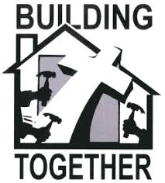

Building the Kingdom of God Together

“But seek ye first the kingdom of God…” (Matt. 6:33a)

The mission of Anson Baptist Association is to assist, resource and inspire our family of churches to take the gospel to the world and to make reproducing disciples of Jesus from all the people of the world.

Anson Baptist Association
P. O. Box 958, 2710 US 74
Wadesboro, NC 28170
Phone: (704) 694-2790
Website: www.ansonbaptist.org
Email: ansonbaptist@yahoo.com

